Create a web page for user registration using HTML, CSS as shown below. Validate the details entered using Javascript.

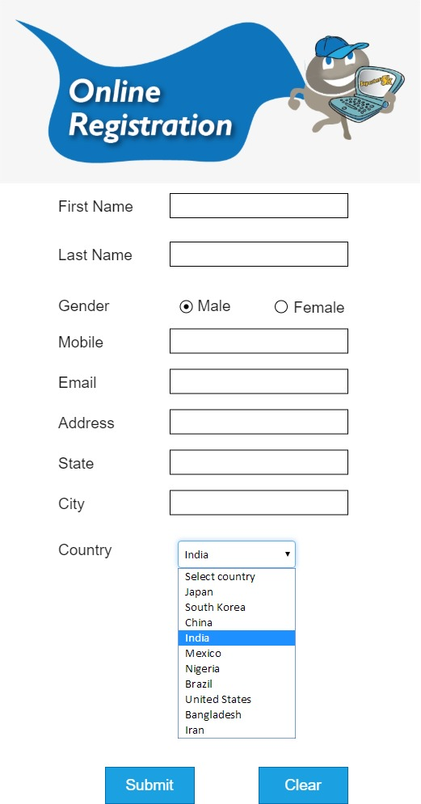

When the user clicks on “Submit” button, validate all entries with the following sample conditions.

1. Name should contain only alphabets
2. Email should have a format of [xyz@gmail.com](mailto:xyz@gmail.com)
3. Password must be of specific length and should contain alphabets, numbers, special characters
4. Mobile number should be of length 10 (Insert country code if required with additional length)

Additionally, customize the form by adding some more fields in the form, apply formatting by adding background image, changing font color for the elements and evaluate the entries. When the user clicks on “Clear” button, all entries should be cleared.